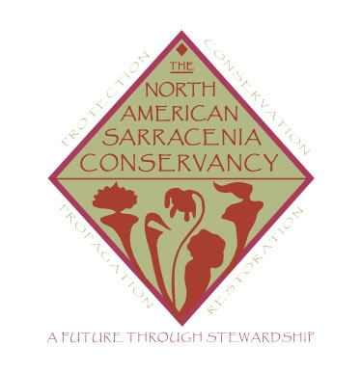

Section A: Organization / Educator Information
Name:
Organization:
Street Address:
City: State: Zip Code:
Phone:
Email address:
Section B: Nonprofit and Educational Seed Request Information
Under the Distribution Committee Policies and Procedures:
      - Nonprofit organizations and entities requesting seed for educational purposes may complete the “Nonprofit and Educational Programming Seed Request” Form and submit it to the Head of Distribution.
      - Documentation and intended goals/outcomes shall be included.
      - The Head of Distribution will review the request with the Board of Directors at the next NASC meeting.
      - If approved, the nonprofit organization or entity requesting seed for educational purposes will be contacted with a notification of approval or denial of requested seed.
      - Packaging materials and shipping costs will be calculated based upon amount of seed requested.

I am requesting seed from the following populations:

1.
2.
3.
4.
5.
6.
7.
8.
9.
10.

Adequate and appropriate documentation outlining the goals and outcomes of seed usage have been attached for review by the NASC Board of Directors. I have read and agree to all parts of the North America Sarracenia Conservancy Policies and Procedures.

Signed: Date:
Section C: Distribution Committee Notes
Seed Distribution Form Received:
Funds Received: H.D. Initials
Seed Shipped: H.D. Initials
Confirmed receipt of seed:

